# **USER MANGEMENT SYSTEM**

# **0.1**

1. ***Objective***

*<To be filled>*

1. ***Approach***

*<<Specify your design approach at high level here>>*

1. ***Service Catalog***

|  |  |  |  |  |
| --- | --- | --- | --- | --- |
| **HTTP Method** | **Service Endpoint** | **Body Parameters** | **Brief Description** | **Comments** |
| POST | login/ | username, password, |  |  |
| POST | logout/ | username, password |  |  |
| POST | create-user/ | user_id, |  |  |
| PUT | update-user/ |  |  |  |
| GET | read-users/ |  |  |  |
| DELETE | delete-users/ |  |  |  |
| POST | create-admin/ |  |  |  |
| GET | read-admins/ |  |  |  |
| PUT | update-admin/ |  |  |  |
| DELETE | delete-admin/ |  |  |  |

1. 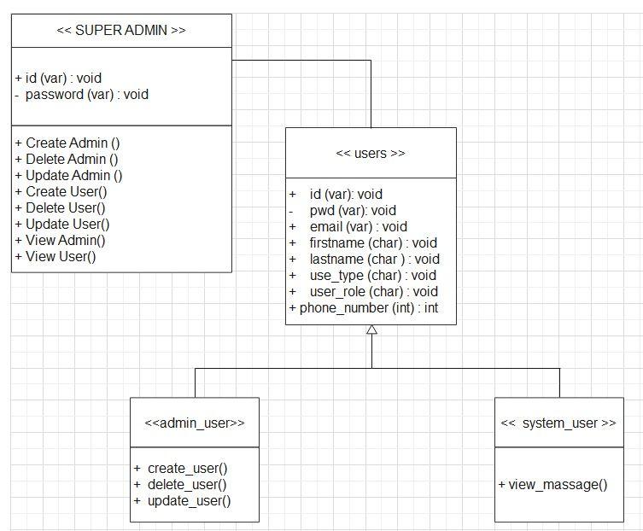***Design Considerations / Models***

|  |  |  |
| --- | --- | --- |
| **Class Name** | **Responsibility** | **Collaborators** |
| Super Admin | To create and supervise admin users and other users | None |
| Admin | To create and supervise other users | None |
| Users | To login and view welcome message | None |

* ***Data Model***

***Table Name : Admin***

|  |  |  |  |  |
| --- | --- | --- | --- | --- |
| Column Name | Data Type with Length | Constraints (if any) | Description | Comments |
| admin_id | String 255 | Primary Key |  |  |
| phone_number | String 12 |  |  |  |
| Email | String 320 |  |  |  |
| password | String (HashedValue) |  |  |  |

***Table Name : Users***

|  |  |  |  |  |
| --- | --- | --- | --- | --- |
| Column Name | Data Type with Length | Constraints (if any) | Description | Comments |
| user_id | String 255 | Primary Key |  |  |
| Phone_number | String 12 |  |  |  |
| Email | String |  |  |  |
| password | String (HashedValue) |  |  |  |

1. ***Error Codes & Messages on various validation scenarios***

|  |  |  |
| --- | --- | --- |
| **Error Scenario** | **Error Code** | **Error Message** |
|  |  |  |
|  |  |  |
|  |  |  |

1. ***UI Wireframes***

*<<If you are able to provide view of how your UI would look like you can add here. Not mandatory>>*